Ex. No. 1 | Design A Website Using HTML5
Date of Exercise | 08/07/2026
GitHub Host Link | https://advaiithh.github.io/WEBTECHNOLOGYLAB/

Aim
To design and develop a simple and structured Astrology & Horoscope Website using HTML5 by implementing semantic HTML elements, headings, paragraphs, images, hyperlinks, tables, lists, forms, and basic CSS formatting.
Description
This experiment involves designing and developing a simple Astrology & Horoscope Website using HTML5. The webpage is created using the HTML5 document structure with essential elements such as <html>, <head>, <meta>, <title>, and <body>. The website is organized using headings, paragraphs, images, tables, lists, hyperlinks, and comments.
The webpage provides information about zodiac signs, horoscope predictions, lucky colors, lucky numbers, astrology terms, and daily astrology tips. Different types of hyperlinks such as internal, external, bookmark, email, telephone, and clickable image links are implemented for easy navigation.
A horoscope request form is included using HTML5 input elements. Basic internal CSS is used to improve the appearance of the webpage by applying suitable background colors, text colors, spacing, and table formatting. This experiment demonstrates the fundamental concepts of HTML5 webpage development and basic web designing.

Procedure:
- Open Visual Studio Code (or any HTML editor) and create a new file named index.html.
- Add the HTML5 document declaration (<!DOCTYPE html>).
- Create the basic HTML structure using <html>, <head>, <meta>, <title>, and <body> tags.
- Set the webpage title as "Astrology & Horoscope Website".
- Create a header section with the website title and navigation menu.
- Add headings and paragraphs describing astrology and horoscope.
- Insert a clickable astrology image using the <img> tag.
- Create a table displaying horoscope predictions for different zodiac signs.
- Add a description list containing important astrology terms.
- Create ordered and unordered nested lists for zodiac signs and lucky things.
- Insert different types of hyperlinks including:
- External hyperlink
- Internal hyperlink
- Bookmark link
- Email link
- Telephone link
- Clickable image link
- Divide the webpage into different sections using <div> elements.
- Save the file and execute it using Live Server or any web browser.
- Verify that all hyperlinks, images, forms, and tables are working correctly.
- Upload the HTML file to GitHub.
- Enable GitHub Pages and copy the hosted website link.

Program:

<!DOCTYPE html>
<html lang="en">
<head>
<meta charset="UTF-8">
<meta name="viewport" content="width=device-width, initial-scale=1.0">
<title>Astrology & Horoscope Site</title>
<style>
body{font-family:Arial,sans-serif;background:#f3ecff;color:#222;margin:20px}
h1,h2,h3{text-align:center}
table{width:100%;border-collapse:collapse}
th,td{border:1px solid #555;padding:8px;vertical-align:top}
.section{margin:20px 0}
.footer{text-align:center;margin-top:20px}
</style>
</head>
<body>

<!-- Header -->
<div id="top">
<h1> ASTROLOGY & HOROSCOPE </h1>
<h3>ADVAITH V | URK24CS1191</h3>
<hr>
<center>
<a href="#about">About</a> |
<a href="#zodiac">Zodiac</a> |
<a href="#horoscope">Horoscope</a> |
<a href="#form">Find Horoscope</a> |
<a href="#contact">Contact</a>
</center>
</div>

<div class="section" id="about">
<h2>Welcome</h2>
<p>Astrology studies the relationship between celestial bodies and human life. Many people use zodiac signs to understand personality, relationships, career and future possibilities.</p>
<p>This website introduces zodiac signs, lucky things, daily horoscope, useful astrology terms and a simple horoscope request form.</p>
</div>

<div class="section">
<center>
<a href="https://www.astrology.com" target="_blank">
<img src="https://www.suvich.com/blog/wp-content/uploads/2021/10/health-astrology.jpg" alt="Astrology" width="350" height="220">
</a>
</center>
</div>

<hr>

<table>
<tr>
<td width="50%" id="zodiac">
<h2>Zodiac Signs</h2>
<ul>
<li>Fire Signs
<ul><li> Aries</li><li> Leo</li><li> Sagittarius</li></ul></li>
<li>Earth Signs
<ul><li> Taurus</li><li> Virgo</li><li> Capricorn</li></ul></li>
<li>Air Signs
<ul><li> Gemini</li><li> Libra</li><li> Aquarius</li></ul></li>
<li>Water Signs
<ul><li> Cancer</li><li> Scorpio</li><li> Pisces</li></ul></li>
</ul>
</td>

<td width="50%">
<h2>Lucky Things</h2>
<ul>
<li>Lucky Colors
<ul><li>Red</li><li>Blue</li><li>Green</li></ul></li>
<li>Lucky Numbers
<ul><li>3</li><li>7</li><li>9</li></ul></li>
<li>Lucky Days
<ul><li>Monday</li><li>Thursday</li><li>Friday</li></ul></li>
</ul>
</td>
</tr>
</table>

<hr>

<table>
<tr>
<td width="50%" id="horoscope">
<h2>Today's Horoscope</h2>
<table>
<tr><th>Zodiac</th><th>Prediction</th></tr>
<tr><td>Aries</td><td>• Great day to start something new.<br>• Your confidence will lead to success.</td></tr>
<tr><td>Taurus</td><td>• Stay patient and positive.<br>• Hard work will bring good results.</td></tr>
<tr><td>Gemini</td><td>• Good news may arrive today.<br>• Spend time with loved ones.</td></tr>
<tr><td>Leo</td><td>• Leadership brings rewards.<br>• A lucky opportunity awaits.</td></tr>
<tr><td>Pisces</td><td>• Trust your instincts.<br>• Family brings happiness.</td></tr>
</table>
</td>

<td width="50%">
<h2>Astrology Terms</h2>
<dl>
<dt><b>Zodiac</b></dt><dd>The twelve astrological signs.</dd>
<dt><b>Horoscope</b></dt><dd>A prediction based on birth details.</dd>
<dt><b>Planet</b></dt><dd>A celestial body used in astrology.</dd>
</dl>
</td>
</tr>
</table>

<hr>
<div class="section" id="contact">
<h2>Contact Us</h2>
<p>Astrology & Horoscope Center</p>
<p>Email: <a href="mailto:contact@astroworld.com">contact@astroworld.com</a></p>
<p>Phone: <a href="tel:+919123456789">+91 9123456789</a></p>
</div>

<hr>

<div class="footer">
<a href="#top">Back to Top</a>
<p><b>ADVAITH V | URK24CS1191</b></p>
</div>

</body>
</html>

Output
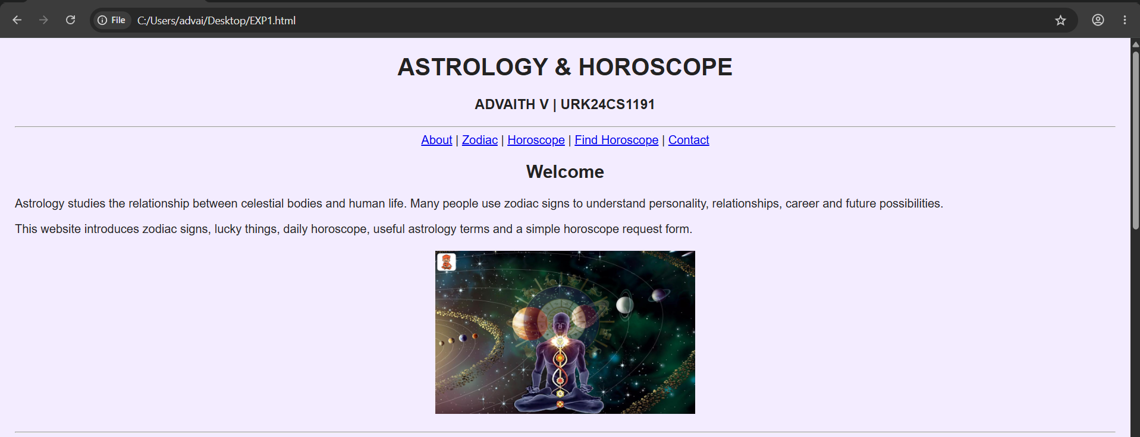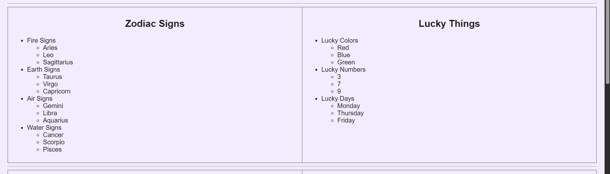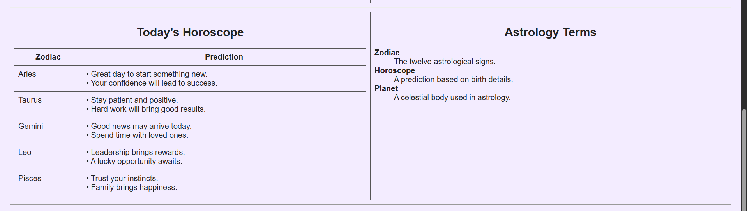
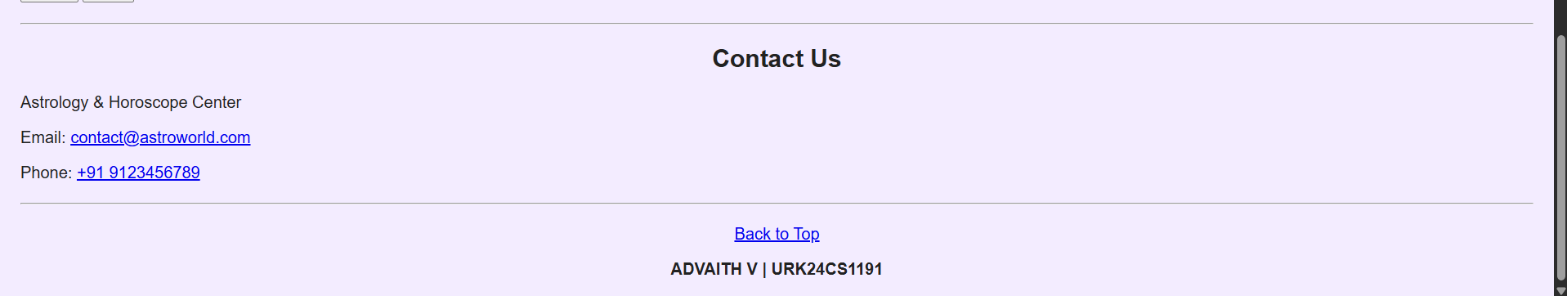

Result
The Astrology & Horoscope Website was successfully designed and developed using HTML5 and basic CSS. The webpage includes semantic HTML elements, headings, paragraphs, images, hyperlinks, tables, nested lists, description lists, forms, and comments. All navigation links, images, and form elements function correctly. The website provides a simple, attractive, and user-friendly interface, successfully achieving the objectives of the experiment.

